TURBINE CONTROL BOARD SPECIFICATION
PB 540

Table of Contents
1. INTRODUCTION 3
1.1 Purpose 3
1.2 Scope 3
1.3 REVISION HISTORY 3
1.4 Reference Documents 3
1.5 Definitions 3
2. Overview 3
3. Electrical Requirements 4
3.1 Specifications 4
3.2 Interconnect 5
3.2.1 Power Supply Input Connector - 1 (J1) 5
3.2.2 Turbine Control Connector -1 (J2) 5
3.2.3 Temperature Sensor Connector (J3) 5
3.2.4 Motor Connection Connector (J6) 5
3.2.5 Power Supply Input Connector - 2 (J11) 6
3.2.6 Turbine Control Connector -2 (J22) 6
4. Mechanical Requirements 7
4.1 Size 7
4.2 Mounting 7
4.3 Cooling 7
4.4 Fabrication 7
4.5 Protection 7
4.6 Labeling 7
5. Packaging Requirements 8

INTRODUCTION

Purpose
The purpose of this document is to provide the requirements for the Turbine Control Board.

Scope
This document provides the requirements for the Turbine Control Board used in the PB640, PB560, PB540, and PB520 devices.

REVISION HISTORY
Revision | Date | Author | Change Description
A | 03/14/08 | T. Dubreuil | Initial Release
B | 09 Sep 08 | T. Dubreuil | Add note on the IPC Class II/III requirement
C | 03-Nov-08 | G. Sánchez | Updated format to standard. Clarified requirements.
D | 20-Jan-2009 | G. Sáanchez | Incorporate updates from Verification Review

Reference Documents
Reference | Part Number | Revision | Document Title
N/A | N/A | N/A | N/A

Definitions
Acronym | Definition
A | Ampere
PCBA | Printed Circuit Board Assembly
V | Volt
RPM | Revolutions per minute

Overview
The Turbine Control board controls speed of the turbine and provides a means to transfer measured feedback signals. The feedback signals consist of turbine speed and temperature. This board also measures the amount of current flowing across turbine motor windings. This board also provides a means of braking (stopping) the turbine.
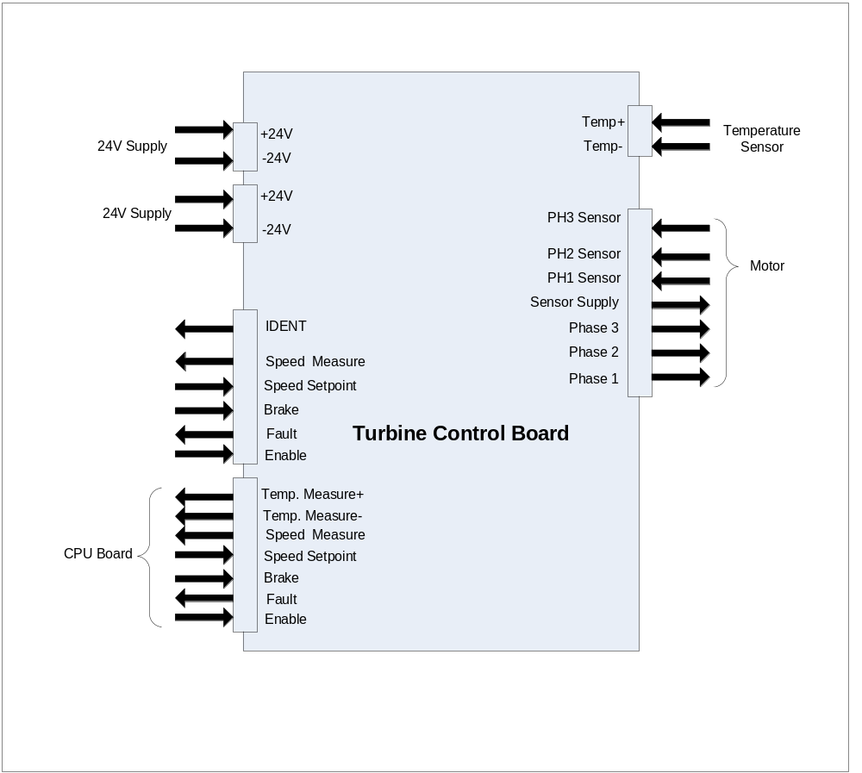

Electrical Requirements

Specifications
HWSTCB1 The Turbine Control Board shall provide a sequential drive signal to three phases of the turbine motor to drive the motor from 0 to 45000 rpm
HWSTCB2 The Turbine Control Board shall monitor motor position through the position sensor input signal.
HWSTCB3 The Turbine Control Board shall act as an interface for transferring the motor temperature signal to the CPU Board.
HWSTCB4 The Turbine Control Board shall provide a means to cut-off the turbine drive circuitry.
HWSTCB5 The Turbine Control Board shall provide a means of braking the turbine motor.
HWSTCB6 The inrush current of the Turbine Control Board shall be less than 4A.
HWSTCB7 The Turbine Control Board shall have an input of 24V +/- 1.2V and produce an output of 15.00V +/- 0.25V with a 3A capacity sourcing.

Interconnect

Power Supply Input Connector - 1 (J1)
Pin Number | Signal Name
1 | - 24V Supply Input
2 | + 24V Supply Input

Turbine Control Connector -1 (J2)
Pin Number | Signal Name
1 | GND
2 | Enable
3 | Fault/
4 | Brake/
5 | Speed – Setpoint
6 | Speed - Measure
7 | NC
8 | NC
9 | Temp. Measure -
10 | Temp. Measure +

Temperature Sensor Connector (J3)
Pin Number | Signal Name
1 | Temp -
2 | Temp +

Motor Connection Connector (J6)
Pin Number | Signal Name
1 | Phase 1
2 | Phase 2
3 | Phase 3
4 | Sensor Supply
5 | GND
6 | PH1 Sensor
7 | PH2 Sensor
8 | PH3 Sensor

Power Supply Input Connector - 2 (J11)
Pin Number | Signal Name
1 | - 24V Supply Input
2 | + 24V Supply Input

Turbine Control Connector -2 (J22)
Pin Number | Signal Name
1 | GND
2 | Enable
3 | Fault/
4 | Brake/
5 | Speed - Setpoint
6 | Speed - Measure
7 | NC
8 | NC
9 | IDENT

Mechanical Requirements

Size
HWSTCB15 The length (L) of the PCBA shall be 92.5mm +/- 1mm
HWSTCB16 The width (W) of the PCBA shall be 72mm +/- 1mm
HWSTCB17 The thickness (T) of the PCBA shall be 1.60mm +/- 0.5mm
T
4 holes for the mounting
L
W

Mounting
HWSTCB18 4 holes Ø 3.5mm shall be plan to fix the Turbine Control board on the device.

Cooling
HWSTCB19 The hot components (IC6, D17, T2, T3, T4, T5, T6, T7, T9) shall be place on the back side of the PCBA to allow for cooling from the metal enclosure of the turbine box.

Fabrication
HWSTCB20 The Printed Circuit Board shall be fabricated per standard IPC-A-610D Class 3. Exception shall be listed on the fabrication drawings.

Protection
N/A.

Labeling
HWSTCB21 The PCBA shall be labeled with its Name, Part Number and Revision which is also human readable.

Packaging Requirements
HWSTCB22 Packaging shall be designed to minimize the level of waste and waste disposal as per the European Directive on handling waste packaging.
Packaging shall be tested to the international standard ISTA2A.

